ATIC Accessibility
To support the accessible community in making informed travel decisions for their individual needs

This report prepared for:
Business name: | Mimbi Caves Campground
Address: | Mount Pierre Station
Town: | Fitzroy Crossing
Contact for enquiries: | Gail Gower
Contact Number: | 0477 355 671
Contact Email: | campground@mimbicaves.com.au
Website: | www.mimbicaves.com.au/campground
Date: | 2026-07-03 15:15

ATIC Accessibility
The following pages provides travellers with information on the businesses facilities and amenities which aims to support the traveller to make an informed decision on whether the business is suitable for their individual needs.
OVERVIEW 4
Business Overview 4
Bookings 4
Emergency Management 4
Communications 5
GENERAL 6
Pre-arrival, arrival and reception 6
Entry 6
Internal Spaces 7
Public areas 7
Displays, exhibits, commentary and live performances 7
External Paths 7
Public Toilets/Adult change facilities 8
TOUR OPERATORS 9
Route Planning 9
Guides 9
ACCOMMODATION 10
Bathrooms 10
ATTRACTIONS 11
Attractions Basics 11
COMMON AREAS 13
Report Disclaimer 15

OVERVIEW

Business Overview

The business has the following products/services available
- Tour/Transport
- Accommodation
- Attraction

Our business caters for the following disability types:
- Deaf or low hearing
- Limited mobility
- Wheelchairs or mobility scooters
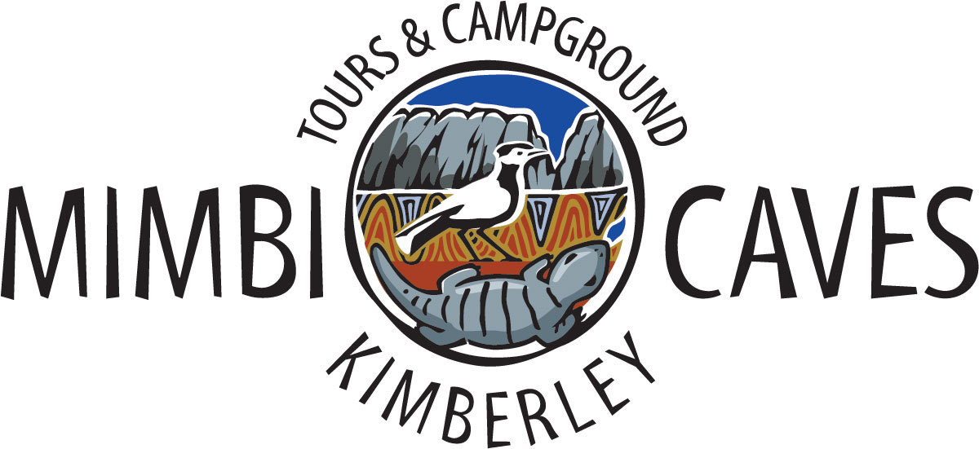

Bookings

The business offers the following methods for bookings and enquiries:
- Phone
- Email
- Webportal
- Our website supports Screen Readers

Emergency Management
- There are Audible device/s to alert occupants to evacuate with instructions on how to evacuate.
- There are visual device/s to alert occupants to evacuate.
- Exit signs are clear and easy to see
- Exit access is free and clear at all times
We ensure exit access is free and clear at all times by:
Internal roads to campgrounds kept free of all physical impediments. All camping sites have own access and exit ways. Mimbi caves walk access kept free of all physical impediments at all times. Campground buildings have accessibility compliant doors.
- Exits and access to exists are greater than 900mm
- Exit doors are able to be opened by all occupants
- Exits to the emergency evacuation point does not include stairways
- The evacuation point is clearly marked by a sign
The business identifies guests who need additional assistance should an emergency occur by:
No established policy or procedure at this point in time.
The procedure for assisting guests who need assisted rescue is:
No established policy or procedure at this point in time.

Communications
- Our business offers the following alternative communication methods
- Plain English

No other
- There is easy to read signage and information (e.g. menus and emergency information)

Tours guides use pen and paper for written word or for the display of images for participants with impaired hearing. Tour operation uses whisper boxes for hearing impaired persons.
The business provides the following services for services animals:
Not specified

GENERAL

Pre-arrival, arrival and reception
The business has the following in place to support guests during pre-arrival, arrival and reception
- There is a reception/public entryway.
- Seating available at reception
- A tablet with text to voice or pen and paper at reception to aid in communication
- Lighting in the reception area is even and glare free
- Information and maps are available in written form
- In addition, the following further information can assist guests:
This does not apply with our business
- In addition, the following further information can assist guests:
N/A
- In addition, the following further information can assist guests:
No additional comments

Entry
The business has the following amenities/systems in place for entry
- A path of access to the building is clear of obstruction
- Self opening entry doors or fitted with a self closer
- Door jams/doors are of a contrasting colour to surrounding walls
- Door handles are of a contrasting colour to the door
- Signage is written in a contrasting colour
- The entry door is a minimum of 850mm wide
- The entry door has self opening or a light opening pressure (for manual operations)
- In addition, the following further information can assist guests:
No additional information
- In addition, the following further information can assist guests:
There are no circumstances where a lift would be required or practical.

Internal Spaces
- Clear and unobstructed routes through and between buildings
- Interior walls are matte or low sheen
- Floors, walls, counters and furniture are of contrasting colours
- Any protruding or overhanging obstructions are at least 2meters above the floor or are protected
- Seating is available for guests unable to stand for long periods
- Accessible facilities are clearly signed and visible from all areas
- All corridors greater than 900mm
- In addition, the following further information can assist guests:
The campground is designed and constructed to provide enough space for a quiet area to be available for anybody requiring such.

Public areas
The public areas have the following amenities in place
- Seating
- In addition, the following further information can assist guests:
No additional information

Displays, exhibits, commentary and live performances
For displays, exhibits, commentary and live performances the following amenities are in place
- Seating
- Wheelchair accessible spaces/seating
- In addition, the following further information can assist guests:
No additional information

External Paths
External paths of travel
- Surfaces are concrete, asphalt, smooth paving or hard packed fine gravel (max aggregate size 13mm)
- Paths or slopes longer than 15 metres have resting places or seats
- Pathways are wider than 900mm
- In addition, the following further information can assist guests:
No additional information
- In addition, the following further information can assist guests:
No additional information

Public Toilets/Adult change facilities
Public Toilets/Adult change facilities have the following amenities are in place
- There is an accessible toilet for public use
- The door is at least 850mm wide
- There is a minimum of 850mm beside the toilet
- Handrails are fitted
- The toilet seat is 460mm above the floor
- The toilet seat of a contrasting colour to the floor
- The toilet seat is460mm above the floor
- There is a 'Changing Place' within There is not a changing place of our business
- In addition, the following further information can assist guests:
No additional information

TOUR OPERATORS

Route Planning
- In addition, the following further information can assist guests:
We do not operate a bus or boat or coach as part of our guided walking tours. Guided tours are walking only. We do provide a complementary bus connection from a large car park to the guided walk commencement but this does not qualify as accessible. Most guided walks participants make their own way to the guided walks commencement point.
- Walking Tours
- Multi-paced to account for slower walkers

Guides

Guides have been trained in the following
- Use of clear/simple English
- Correct pronunciation for lip readers
- In addition, the following further information can assist guests:
No additional information

ACCOMMODATION

Accommodation for visitors only includes camping sites. Two of the camping sites have safari tents but these are not accessible.
- Openings are a minimum of The business does not provide accommodation rooms. wide
- In addition, the following further information can assist guests:
No additional information

Bathrooms
The bathrooms have the following facilities/amenities in place
- All heating appliances and hot water pipes are protected or insulated
- All shower, bath and basin taps are clearly differentiated between hot and cold
- Fixtures and fittings have rounded edges
- The hot water is thermostatically controlled to 41 degrees
- The door is at least 850mm wide
- There is a minimum of 850mm beside the toilet
- Handrails are fitted
- There is a minimum of 1400mm of clear space in front of the toilet
- The toilet seat is a contrasting colour to the floor
- The toilet seat is 460mm above the floor
- There is a roll-in shower with fold down fixed seat or a shower chair
- There is a portable shower head on flexible hose
- A door is fitted to the shower
- A door is fitted to the showers with an outward swing at minimum width of 900 mm

ATTRACTIONS

Attractions Basics
- A park map is available here:

https://www.mimbicaves.com.au
  - Image(s)
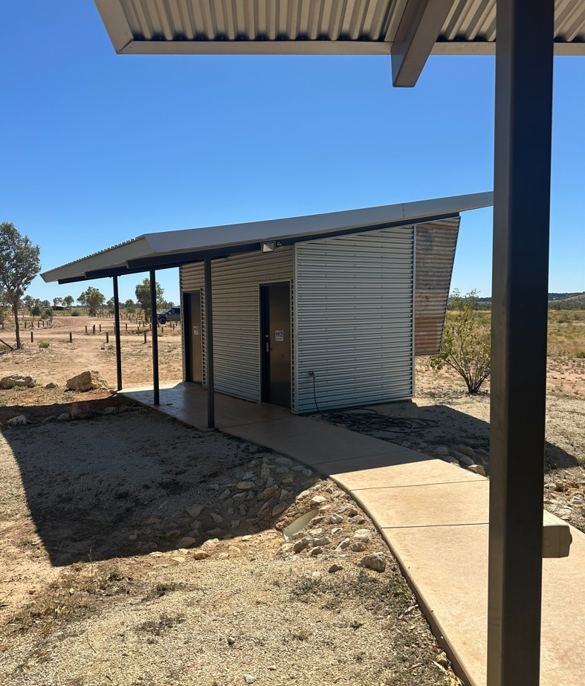
Mimbi campground accessible toilet outside
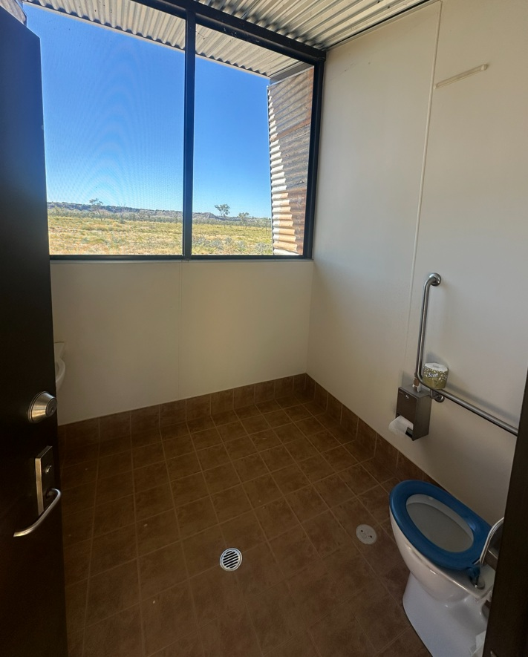
Mimbi campground accessible toilet inside
- In addition, the following further information can assist guests:
An accessible toilet is available at one of the ablution blocks at the visitor campground, and this is available to anybody who visits Mimbi for camping or to participate in a tour. There are no accessible toilets available at any other point at Mimbi.&nbsp;

COMMON AREAS

Report Disclaimer
Please note that this business report, provided as a result of the use of the diagnostic assessment, is for information purposes only.
Australian Tourism Industry Council (ATIC) cannot guarantee the accuracy of respondent’s answers, or that they are fully representative of your business. Therefore, ATIC does not warrant or guarantee any particular outcome in respect of your businesses self-assessment.
This report is intended as guidance only for your business and should not be relied on for future marketing considerations. ATIC recommends that you seek your own independent advice as well as the results from the diagnostic.
Links to external web sites are inserted for convenience and do not constitute endorsement of material at those sites, or any associated organisation, product or service.
ATIC does not:
- Assume any legal liability for the accuracy, completeness, or usefulness of any information from this report or any links provided; or
- Accept responsibility for any loss associated directly or indirectly from the use of this report.

